1. **Include in** program.cs

**[STAThread]**

static void Main(string[] args) ....

&#xf1;

1. **INSTALL Selenium**

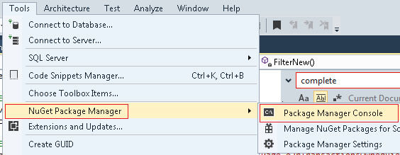

1. **PM> Install-Package Selenium.WebDriver**
2. **PM>** Install-Package Selenium.WebDriver.ChromeDriver
3. **update-package**
4. **INSTALL WatiN**

**PM> Install-Package WatiN**

1. **Install Interops**

**PM> Install-Package Microsoft.VisualStudio.Shell.Interop**

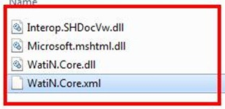

1. **Include for Selenium Chrome**

using OpenQA.Selenium;

using OpenQA.Selenium.Chrome;

1. **Install Chrome Browser : Chrome**

<https://www.google.com/chrome/browser/features.html?utm_source=bing&utm_medium=sem&utm_campaign=1001342%7cChromeWin10%7cUS%7cen%7cHybrid%7cText%7cBKWS~TopKWDS-Exact&brand=CHBF&utm_source=bing&utm_medium=cpc&utm_campaign=1001342%20%7C%20Chrome%20Win10%20%7C%20US%20%7C%20en%20%7C%20Hybrid%20%7C%20Text%20%7C%20BKWS%20~%20Top%20KWDS%20-%20Exact&utm_term=chrome&utm_content=Chrome%20-%20Exact&dclid=CJ7BzsOU99MCFUM2lgodzfwH1w>

**INSTALL UI AUTOMATION**

INCLUDE UIAutoamtionClient

Reference / Add Reference /Assemblies

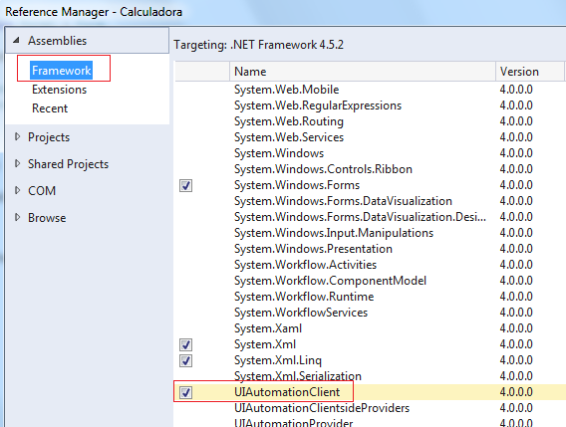

ALSO INCLUDE UIAutomationTypes.dll

Which is in

C:\Windows\Microsoft.NET\assembly\GAC_MSIL\UIAutomationTypes\v4.0_4.0.0.0__31bf3856ad364e35